Specialized Training Seminar
RENEWABLE ENERGY SOURCES
Event Venue – June 5-6, 2016
Event Venue
Name: | Prof. Michele ANATONE
Affiliation: | University of L’Aquila, Italy
Host Institution: | University Abou Bekr BELKAID, Tlemcen, ALGERIA
Program Date: | June 5 - 6, 2016
Contacts: | Tel: +39 328 0085313, Email: michele.anatone@univaq.it

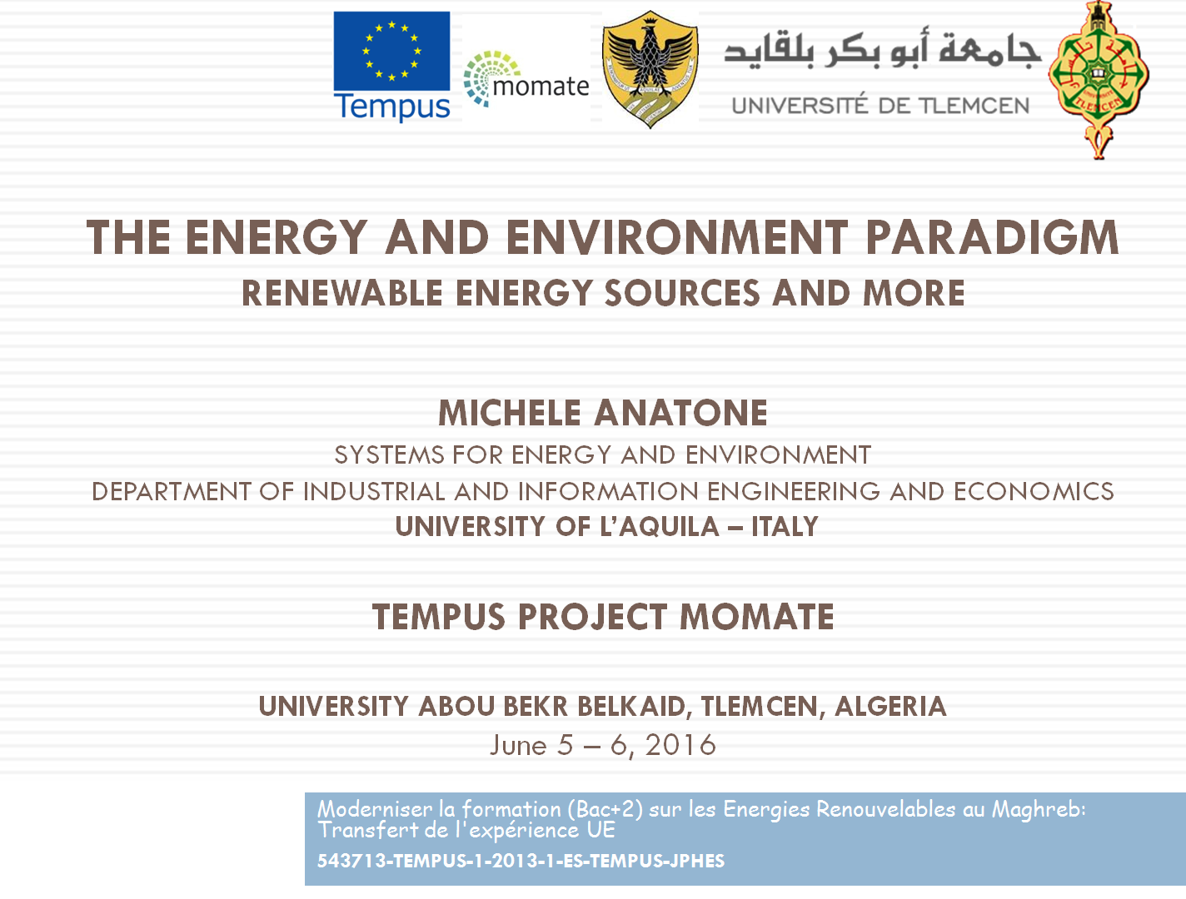
TOPICS

- The limit to the growth
- From the growth to the sustainable development
- The RES
- The Sun
- The Wind
- The Biomass
- The Hydropower
- The Geothermal
- Integration of technologies
- The Life Cycle Assessment (LCA) procedure

Professor Michele ANATONE
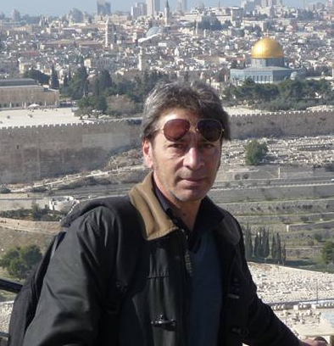 | Michele Anatone is professor in Mechanical Engineering at the University of L’Aquila in the field of “Systems for Energy and Environment”. He teaches topics related to ground vehicles traction systems; Power Plants, Internal Combustion Engines, Pumps and Compressors. His research activities are focused on modeling and experimentation of the thermo-fluidynamic processes in Internal Combustion Engines, on alternative propulsion systems for the sustainable mobility. He is active in the development of innovative technologies particularly related to ground vehicles field such as electrical hybrid systems. Among his activities related to society, he works for the development of procedures for local energy planning and for distributed generation.  He is member of Doctoral Program Board in Mechanical Engineering. He is author and co-author of about 70 scientific journal and conference papers, as well as supervisor of many doctoral and master thesis.  He is in charge of the local coordination of Tempus Projects on sustainable mobility and energy conversion technologies.

